**PROJEXA**

A PROJECT REPORT

Submitted By

**AFRAKE**

**TVE24MCA-2008**

**To**

The APJ Abdul Kalam Technological University

in partial fulfillment of the award of the degree

**of**

Master of Computer Applications

**Department of Computer Applications**

College of Engineering Trivandrum

Trivandrum

November 2025

**Declaration**

I undersigned hereby declare that the project report titled “**Player Auction**” submitted for partial fulfillment of the requirements for the award of the degree of Master of Computer Applications of the APJ Abdul Kalam Technological University, Kerala is a Bonafide work done by me under the supervision of **Prof. Sunitha D, Assistant Professor.** This submission represents my ideas in my own words and where ideas or words of others have been included. I have adequately and accurately cited and referenced the sources. I also declare that I have adhered to the ethics of academic honesty and integrity as directed in the ethics policy of the college and have not misrepresented or fabricated any data or idea or fact or source in my submission. I understand that any violation of the above will be a cause for disciplinary action by the Institute and/or University and can also evoke penal action from the sources which have thus not been properly cited or from whom proper permission has not been obtained. This report has not previously formed the basis for the award of any degree, diploma, or similar title.

Place : Trivandrum **TITTU THOMAS GEORGY**

Date : 055/04/2025

**DEPARTMENT OF COMPUTER APPLICATIONS**

**COLLEGE OF ENGINEERING**

**TRIVANDRUM**



**CERTIFICATE**

This is to certify that the report entitled **PLAYER AUCTION** submitted by **Tittu Thomas Georgy** to the APJ Abdul Kalam Technological University in partial fulfillment of the requirements for the award of the Degree of Master of Computer Applications is a bonafide record of the project work carried out by him under my guidance and supervision. This report in any form has not been submitted to any University or Institute for any purpose.

Guide Supervisor

Head of the Department

**Acknowledgment**

First and foremost I thank GOD almighty and my parents for the success of this project. I owe sincere gratitude and heart-full thanks to everyone who shared their precious time and knowledge for the successful completion of my project.

I am extremely thankful to **Dr. Suresh K**, Principal, College of Engineering Trivandrum for providing me with the best facilities and atmosphere which was necessary for the successful completion of this project.

I am extremely grateful to **Dr. Liji P I**, HOD, Department of Computer Applications, for providing me with the best facilities and atmosphere for creative work guidance and encouragement.

I express my sincere thanks to **Prof. Deepa S**, Assistant Professor, Department of Computer Applications, College of Engineering Trivandrum for her valuable guidance, support, and advice that aided in the successful completion of my project.

I profusely thank the other Asst. Professors in the department and all other staff of CET, for their guidance and inspiration throughout my course of study.

I owe my thanks to my friends and all others who have directly or indirectly helped me in the successful completion of this project. No words can express my humble gratitude to my beloved parents and relatives who have been guiding me in all walks of my journey.

**Afrake**

**CONTENTS**

**Abstract**

**1: Introduction 1**

**2: Problem Definition and Motivation 2**

2.1 Existing System 2

2.1.1 Limitations of Existing System 2

2.2 Proposed System 3

2.2.1 Advantages of Proposed System 4

**3: Requirement Analysis 5**

3.1 Purpose 5

3.2 Overall Description 5

3.2.1 Hardware Requirements 5

3.2.2 Software Requirements 6

3.3 Functional Requirements 6

3.3.1 React JS, MUI 6

3.3.2 Express JS, NodeJS 6 3.3.3 MongoDB 6

3.3.4 WebSocket 6

3.4 Non-Functional Requirements 7

3.4.1 Performance Requirements 7

3.4.2 Security Requirements 7 3.4.3 Real-Time Performance 7

**4: Design and Implementation 8**

4.1 Overall Design 8

4.2 System Design 8

4.2.1 Database Schema 8

4.2.2 Backend Architecture 8

4.2.3 Real-Time Communication via WebSocket 9

4.2.4 Frontend Framework 9

4.3 Data Flow Diagram 9

4.4 Database Design 11

4.5 Screenshots of User Interface 15

**5: Coding 24**

5.1 Introduction 24

5.2 React 24

5.3 Express 25

5.4 Material-UI (MUI) 25

5.5 Sample Coding 25

5.5.1 App.tsx 25

5.5.2 Server.ts 28

**6: Testing and Implementation 31**

6.1 Introduction 31

6.2 Testing Methods 31

6.2.1 Unit Testing 31

6.2.2 Integration Testing 31

6.2.3 Alpha Testing 32

6.2.4 BetaTesting 32

6.3 Test Cases 32

**7: Results and Discussion 37**

7.1 Advantages and Limitations 37

7.1.1 Advantages 37

7.1.2 Limitations 38

**8: Conclusion and Future Scope 39**

8.1 Conclusion 39

8.2 Future Scope and Enhancements 39

**Bibliography 41**

**LIST OF FIGURES**

**4.3.1:** Level 0 of Data Flow Diagram 9

**4.3.2:** Level 1 of Data Flow Diagram 10

**4.3.3:** Level 2 of Data Flow Diagram (Admin) 10

**4.3.4:** Level 2 of Data Flow Diagram (Club) 11

**4.5.1:** Login Page 15

**4.5.2:** Admin Home Page 16

**4.5.3:** Admin Auction Page 16

**4.5.4:** Admin Player Sold 17

**4.5.5:** Admin Clubs Page 17

**4.5.6:** Admin Add Page 18

**4.5.7:** Admin Club View 18

**4.5.8:** Admin Players Page 19

**4.5.9:** Admin Add Player 19

**4.5.10:** Admin Player View 20

**4.5.11:** Admin Settings Page 20

**4.5.12:** Club Homepage 21

**4.5.13:** Club Auction Page 21

**4.5.14:** Club Auction Place Bid 22

**4.5.15:** Club Player View 22

**4.5.16:** Club Profile View 23

**4.5.17:** Club Auction View Mobile 23

**LIST OF TABLES**

**4.4.1:** Clubs DB 11

**4.4.2:** PlayersDB 12

**4.4.3:** Bids DB 12

**4.4.4:** Auctions DB 13

**4.4.5:** Settings DB 13

**4.4.6:** File DB 14

**6.3.1:** Admin Test Cases 33

**6.3.2:** Club Test Cases 33

**6.3.3:** Player Test Cases 34

**6.3.4:** File Uploads Test Cases 35

**6.3.5:** Settings Test Cases 35

**6.3.6:** Database Integrity Test Cases 36

**Abstract**

Projexa is a comprehensive Academic Project Management System designed to streamline the complete workflow of academic projects in colleges and universities. Built using modern web technologies including Next.js 15, TypeScript, Supabase, and TailwindCSS, the system facilitates seamless project submission, review, evaluation, and communication throughout multiple project phases.

The platform serves three distinct user roles: Administrators, Students, and Guides (Teachers), each with specialized dashboards and permissions. Administrators can manage users, define project phases with rubrics and deadlines, and oversee the entire academic workflow. Students can register projects, submit work through multiple review phases, and track their progress with real-time feedback. Guides are automatically assigned projects based on their specialization and can evaluate submissions, provide feedback, and award marks.

Key features include automated rubric validation for PDF submissions, plagiarism detection through text similarity analysis, real-time leaderboards, automated deadline reminders, and comprehensive notification systems. The system employs Supabase for backend services including authentication, database management, and file storage, while Next.js provides a robust, scalable frontend architecture.

The platform addresses common challenges in academic project management such as manual evaluation processes, lack of transparency, inefficient communication, and difficulty in tracking student progress. By automating routine tasks and providing real-time insights, Projexa enhances the academic experience for all stakeholders while maintaining data integrity and security.

Through its role-based access control, automated workflows, and responsive design, Projexa represents a modern solution to academic project management, ensuring efficient collaboration between students, guides, and administrators throughout the academic project lifecycle.

**Chapter 1**

**Introduction**

Academic project management in educational institutions has traditionally been a complex, manual process involving multiple stakeholders, extensive paperwork, and challenging coordination between students, faculty, and administrators. The conventional approach to managing academic projects often leads to inefficiencies, communication gaps, delayed feedback, and difficulty in tracking student progress across multiple project phases.

In the modern educational landscape, there is an increasing need for digital transformation to enhance learning experiences and streamline administrative processes. Educational institutions require robust systems that can handle the complexity of academic project workflows while maintaining transparency, accountability, and effective communication among all participants.

Projexa emerges as a comprehensive solution to address these challenges by providing a full-stack web application that manages the complete academic project workflow. Built using cutting-edge technologies including Next.js 15 with App Router, TypeScript, Supabase, and TailwindCSS, the platform offers a modern, scalable, and user-friendly approach to academic project management.

The system is designed around three core user roles: Administrators who oversee the entire academic framework, Students who submit and track their project progress, and Guides (Teachers) who evaluate and provide feedback on student submissions. Each role is equipped with specialized dashboards and tools tailored to their specific responsibilities and workflows.

Projexa automates critical processes such as project submission validation through rubric checking, plagiarism detection using text similarity analysis, automated guide assignment based on specialization matching, and real-time progress tracking through comprehensive dashboards. The platform also incorporates advanced features like automated deadline reminders, late submission penalties, real-time leaderboards, and seamless communication channels.

By leveraging modern web technologies and cloud-based infrastructure, Projexa ensures scalability, security, and accessibility while providing an intuitive user experience across all devices. The system represents a significant step forward in digitalizing academic processes, making project management more efficient, transparent, and engaging for all stakeholders in the educational ecosystem.

**Chapter 2**

**Problem Definition and Motivation**

The management of academic projects in educational institutions presents numerous challenges that affect students, faculty, and administrators alike. Traditional methods of handling project submissions, evaluations, and communications are often inefficient, time-consuming, and prone to errors. These limitations necessitate the development of a comprehensive digital solution that can address the complexities of modern academic project management.

The motivation for developing Projexa stems from the need to create a centralized, automated, and transparent system that enhances the academic experience while reducing administrative burden. Educational institutions require a platform that can adapt to diverse academic requirements, support multiple project phases, and provide real-time insights into student progress and performance..

# **2.1 Existing System**

Currently, most educational institutions rely on manual or semi-automated systems for managing academic projects. These systems typically involve physical submission of documents, email-based communications, spreadsheet tracking, and manual evaluation processes. Some institutions use basic learning management systems (LMS) that lack specialized features for project management workflows.

The existing approach often involves students submitting printed reports to faculty members, who then manually evaluate submissions against predefined rubrics. Communication between students and guides typically occurs through email or in-person meetings, making it difficult to maintain consistent records and track progress effectively. Administrative tasks such as deadline management, grade compilation, and progress reporting are often handled manually using spreadsheets or basic database systems.

# **2.1.1 Limitations of Existing System**

1. **Manual Submission Process –** Physical or email-based submissions create bottlenecks and increase the risk of lost documents or missed deadlines.
2. **Lack of Standardized Evaluation** – Without automated rubric checking, submissions may not meet required standards, leading to inconsistent evaluations.
3. **Poor Communication Channels** – Email-based communication makes it difficult to maintain organized project discussions and feedback history.
4. **No Real-time Progress Tracking –** Students and administrators lack visibility into project status and progress across different phases.
5. **Limited Plagiarism Detection –** Manual checking for topic similarity and originality is time-consuming and often incomplete
6. **Delayed Feedback and Notifications** – Students may not receive timely updates about deadlines, evaluation results, or important announcements.

Despite transitioning towards digital tools, existing platforms still fail to provide an efficient, transparent, and automated solution tailored specifically for football player auctions.

# **2.2 Proposed System**

Projexa is designed as a comprehensive Academic Project Management System that addresses all the limitations of traditional approaches through intelligent automation, real-time collaboration, and modern web technologies. The system provides a centralized platform where students, guides, and administrators can efficiently manage the entire project lifecycle.

* **Role-based Access Control** – Distinct dashboards and permissions for Administrators, Students, and Guides.
* **Automated Project Workflow** – Streamlined processes from project registration to final evaluation.
* **Intelligent Rubric Validation** – Automatic checking of PDF submissions against predefined rubrics.
* **Smart Guide Assignment** – Automatic assignment based on specialization matching.
* **Real-time Plagiarism Detection** – Text similarity analysis against previous project topics.
* **Secure File Management** –Cloud-based storage with secure access controls.
* **Live Progress Tracking** – Real-time leaderboards and progress monitoring.

# **2.2.1 Advantages of Proposed System**

* **Enhanced Efficiency** – Automated workflows reduce manual intervention and processing time.
* **Improved Transparency** – Real-time tracking and centralized communication provide clear visibility into project status.
* **Quality Assurance** – Automated rubric validation ensures submissions meet academic standards before evaluation.
* **Fair Evaluation Process** – Standardized evaluation criteria and automated assignment prevent bias and ensure consistency.
* **Better Communication** – Centralized messaging and notification systems improve coordination between all stakeholders.
* **Data-Driven Insights** – Comprehensive analytics and reporting capabilities support informed decision-making.

Projexa represents a paradigm shift in academic project management, transforming traditional manual processes into an intelligent, automated, and user-centric system that benefits all stakeholders in the educational ecosystem.

**Chapter 3**

**Requirement Analysis**

The requirement analysis defines the comprehensive specifications and criteria necessary for the successful development and implementation of Projexa. This analysis encompasses hardware and software requirements, functional capabilities, and non-functional attributes essential for creating a robust academic project management platform.

# **3.1 Purpose**

The purpose of this requirement analysis is to establish clear specifications for the development of Projexa, ensuring that all stakeholder needs are addressed and that the system meets the complex demands of modern academic project management. This analysis serves as the foundation for system design, development, and testing phases.

# **3.2 Overall Description**

# **3.2.1 Hardware Requirements**

* Processor - Pentium 3
* RAM - 512 MB
* Hard Disk - 20 GB
* Cache Memory - 512KB
* Monitor - SVGA Colour
* Keyboard - Standard

# **3.2.2 Software Requirements**

* Operating System - Windows 8/9/10/11
* Front End - Next Js
* Back End - Supabase
* Database - PostgreSQL
* Browser - Edge, Firefox, Chrome

# **3.3 Functional Requirements**

### **3.3.1 Next.js with TypeScript**

The frontend of Projexa will be developed using Next.js 15 with the App Router, providing server-side rendering, static site generation, and optimal performance. TypeScript will ensure type safety, better code quality, and enhanced developer experience. The App Router architecture will enable file-based routing, nested layouts, and efficient data fetching strategies.

### **3.3.2 Supabase Backend**

* PostgreSQL Database: Robust relational database with advanced features.
* Authentication System: Secure user authentication with role-based access.
* Real-time Subscriptions: Live updates for collaborative features.
* Storage Service: Secure file upload and management for PDF submissions.
* Edge Functions: Serverless functions for custom business logic.
* API Generation: Automatic REST and GraphQL API generation.

### **3.3.3 TailwindCSS**

TailwindCSS will be used for styling and responsive design, providing:

* Utility-first Approach: Rapid UI development with utility classes.
* Responsive Design: Mobile-first responsive layouts.
* Customization: Easy theming and design system implementation.
* Performance: Optimized CSS with unused styles purged in production.

### **3.3.4 Email Integration**

Email notifications will be implemented using Resend or Nodemailer to provide:

* Automated Notifications: Deadline reminders, submission confirmations.
* Status Updates: Project approval, rejection, and evaluation notifications.
* Communication: Direct messaging between students and guides.
* Alerts: System announcements and important updates.

## **3.4 Non-Functional Requirements**

### **3.4.1 Performance Requirements**

The system must deliver optimal performance under various load conditions:

* Response Time: Page load times under 2 seconds for 95% of requests.
* Concurrent Users: Support for 500+ simultaneous users.
* File Upload: Efficient handling of PDF files up to 10MB.
* Database Queries: Optimized queries with response times under 100ms.
* Caching: Implement appropriate caching strategies for improved performance.

### **3.4.2 Security Requirements**

Comprehensive security measures will be implemented:

* Authentication: Multi-factor authentication support.
* Authorization: Role-based access control with fine-grained permissions.
* Data Encryption: End-to-end encryption for sensitive data.
* Input Validation: Server-side validation for all user inputs.
* SQL Injection Protection: Parameterized queries and input sanitization.
* Cross-Site Scripting (XSS) Prevention: Content Security Policy implementation.
* Secure File Upload: Malware scanning and file type validation.

### **Scalability Requirements**

The system architecture must support growth and scalability:

* Horizontal Scaling: Ability to scale across multiple server instances.
* Database Scaling: Efficient database design with indexing strategies.
* CDN Integration: Content delivery network for global performance.
* Load Balancing: Distribution of traffic across multiple servers.
* Microservices Architecture: Modular design for independent scaling.
* Caching Layers: Multiple levels of caching for improved performance.

**Chapter 4**

**Design and Implementation**

# **4.1 Overall Design**

The overall design of Projexa focuses on creating a scalable, maintainable, and user-centric academic project management system. The architecture follows modern web development principles with a clear separation of concerns, modular design, and responsive user interfaces. The system is designed to handle complex academic workflows while maintaining simplicity for end users.

# **4.2 System Design**

The system design emphasizes modern web architecture patterns, leveraging the strengths of each technology in the stack to create a cohesive and powerful platform.

# **4.2.1 Database Schema**

The database schema is designed using PostgreSQL through Supabase, providing ACID compliance, advanced querying capabilities, and excellent performance. The schema follows normalized design principles to eliminate data redundancy while maintaining referential integrity through well-defined relationships.

# **4.2.2 Backend Architecture**

The backend architecture leverages Supabase's comprehensive suite of services:

* **Database Management**: PostgreSQL with automatic API generation, providing REST and GraphQL endpoints for all database operations. Row Level Security (RLS) policies ensure data access is properly controlled based on user roles and permissions.
* **Authentication Service**: Supabase Auth handles user registration, login, password reset, and session management. Custom claims and metadata support role-based access control across the application.
* **Storage Service**: Secure file storage for PDF submissions with automatic virus scanning, file type validation, and access control. Signed URLs provide secure, time-limited access to files.
* **Edge Functions**: Serverless functions handle complex business logic such as rubric validation, plagiarism detection, and automated notifications.

# **4.2.3 Authentication System**

The authentication system implements a comprehensive security model:

* User Registration: New users register through Supabase Auth with metadata fields for name, role, department, and specialization. Database triggers automatically create user profiles in the users table.
* Role-Based Access Control**: Three distinct roles (Admin, Student, Guide) with specific permissions and dashboard access. Middleware functions enforce role-based routing and API access.
* Session Management: Secure session handling with automatic token refresh and proper logout procedures. Sessions are validated on both client and server sides.
* Security Features: Password strength requirements, rate limiting on authentication endpoints, and optional two-factor authentication support.

# **4.2.4 Front-end Framework**

* Server-Side Rendering: Improved SEO and initial page load performance through SSR.
* Static Site Generation : Pre-rendered pages for better performance where appropriate.
* Client-Side Navigation: Smooth navigation between pages without full page reloads.
* Code Splitting: Automatic code splitting for optimal bundle sizes.
* Image Optimization: Next.js Image component for optimized image loading.
* TypeScript Integration: Full TypeScript support for type safety and better developer experience.

# **4.3 Data Flow Diagram**

**Level 0 of Data Flow Diagram:**

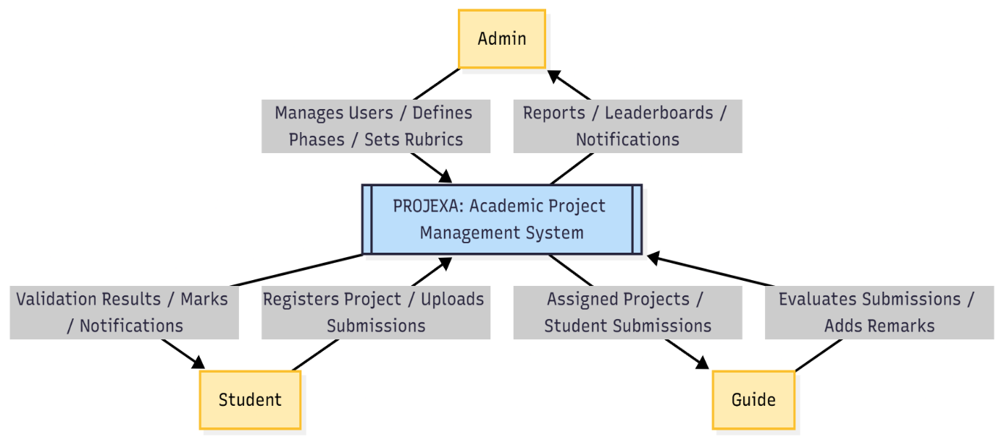

**Fig 4.3.1:** Level 0 of Data Flow Diagram

**Level 1 of DFD:**

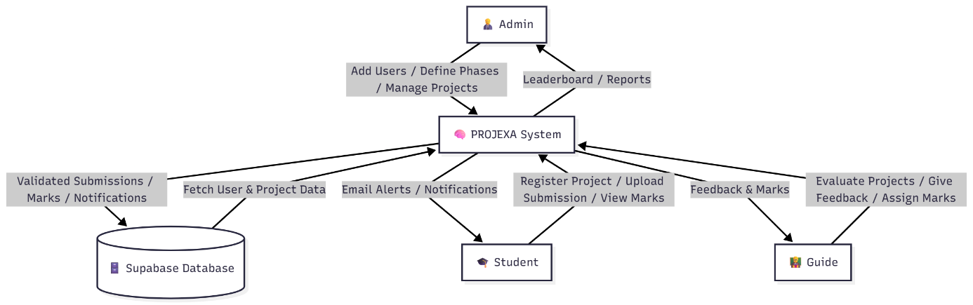

**Fig 4.3.2:** Level 1 of Data Flow Diagram

# **4.4 Database Design**

|  |  |  |  |
| --- | --- | --- | --- |
| **Field** | **Type** | **Key** | **Description** |
| id | UUID | Primary Key | Unique identifier from Supabase |
| name | Text | - | Full name of the user |
| email | Text | Unique | Email address for authentication |
| role | Text | - | User role (admin, student, guide) |
| department | Text | - | Academic department |
| specialization | Text | - | Area of expertise (for guides) |
| year | SMALLINT | - | Academic year (for students) |
| semester | SMALLINT | - | Current semester (for students) |
| created_at | Timestamp | - | Account creation timestamp |

**Table 4.4.1 : Users Table**

|  |  |  |  |
| --- | --- | --- | --- |
| **Field** | **Type** | **Key** | **Description** |
| id | UUID | Primary Key | Unique project identifier |
| title | Text | - | Project title |
| description | Text | - | Project description |
| student_id | UUID | Foreign Key | Reference to users table |
| guide_id | UUID | Foreign Key | Assigned guide reference |
| department | Text | - | Project department |
| status | project_status | Foreign Key | Project status (pending, approved, etc.) |
| created_at | Timestamp | - | Project creation timestamp |
| updated_at | Timestamp | - | Last modification timestamp |
| admin_project_id | UUID | Foreign Key | Reference to admin projects |
| similarity_score | Integer | - | Plagiarism detection score |
| project_name | Text | - | Specific project name for identification |

**Table 4.4.2 : Projects Table**

|  |  |  |  |
| --- | --- | --- | --- |
| **Field** | **Type** | **Key** | **Description** |
| id | UUID | Primary Key | Unique phase identifier |
| name | Text | - | Phase name (e.g., "Review 1") |
| description | Text | - | Phase description |
| deadline | Timestamp | - | Submission deadline |
| max_marks | Real | - | Maximum marks for phase |
| late_penalty_per_day | Real | - | Late_penalty_per_day |
| department | Text | - | Target department |
| created_by | UUID | Foreign Key | Admin who created the phase |
| created_at | Timestamp | - | Phase creation timestamp |
| project_id | UUID | Foreign Key | Associated admin project |

**Table 4.4.3 : Phases Table**

|  |  |  |  |
| --- | --- | --- | --- |
| Field | Type | Key | Description |
| id | UUID | Primary Key | Unique rubric identifier |
| phase_id | UUID | Foreign Key | Associated phase |
| name | Text | - | Rubric name/requirement |
| description | Text | - | Detailed rubric description |
| created_at | TImestamp | - | Rubric creation timestamp |

**Table 4.4.4 : Rubrics Table**

|  |  |  |  |
| --- | --- | --- | --- |
| **Field** | **Type** | **Key** | **Description** |
| _id | ObjectId | Primary Key | Unique identifier for settings |
| initialBalance | Number | - | Initial balance for each club |
| playersPerClub | Number | - | Max number of players per club |
| bidTime | Number | - | Time limit for each bid |
| addOnTime | Number | - | Additional time on last-second bids |
| bidMultiple | Number | - | Minimum increment in bidding |
| keepMinBid | Boolean | - | Whether minimum bid is enforced |
| minBid | Number | - | Minimum bid amount |
| resetPassword | String | - | Password reset field |
| createdAt | Date | - | Timestamp when settings were created |
| updatedAt | Date | - | Timestamp of last update |

**Table 4.4.5 : Settings DB**

|  |  |  |  |
| --- | --- | --- | --- |
| **Field** | **Type** | **Key** | **Description** |
| _id | ObjectId | Primary Key | Unique identifier for file |
| filename | String | - | Name of the file |
| size | Number | - | File size in bytes |
| type | String | - | MIME type (image/png, image/jpeg, etc.) |
| fileId | String | - | Unique file identifier |
| downloadURL | String | - | URL for downloading file |
| createdAt | Date | - | Timestamp when file was uploaded |
| updatedAt | Date | - | Timestamp of last update |

**Table 4.4.6 : File DB**

# **4.5 Screenshots of User Interface**



**Figure 4.5.1 : Login Page**

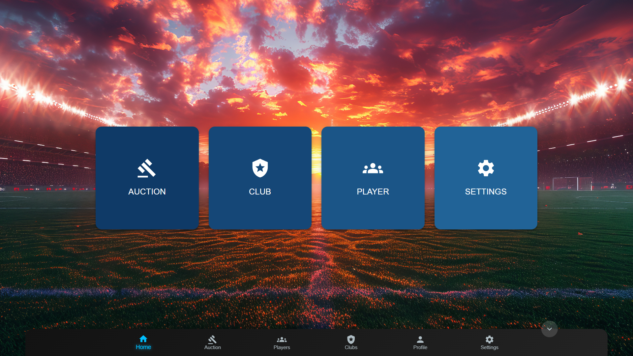

**Figure 4.5.2: Admin Home Page**



**Figure 4.5.3: Admin Auction Page**

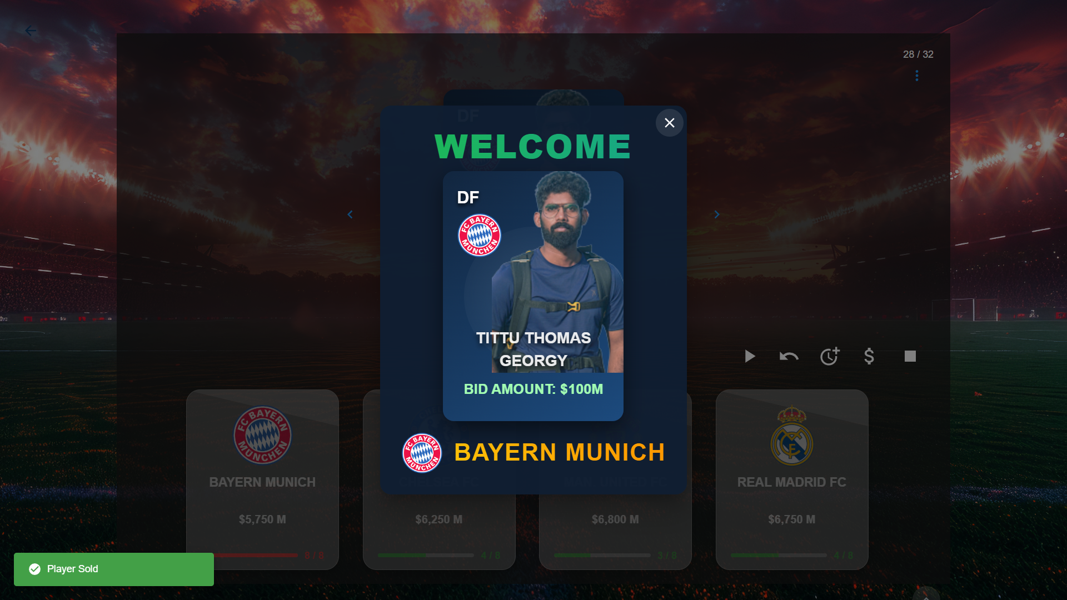

**Figure 4.5.4: Admin Player Sold**

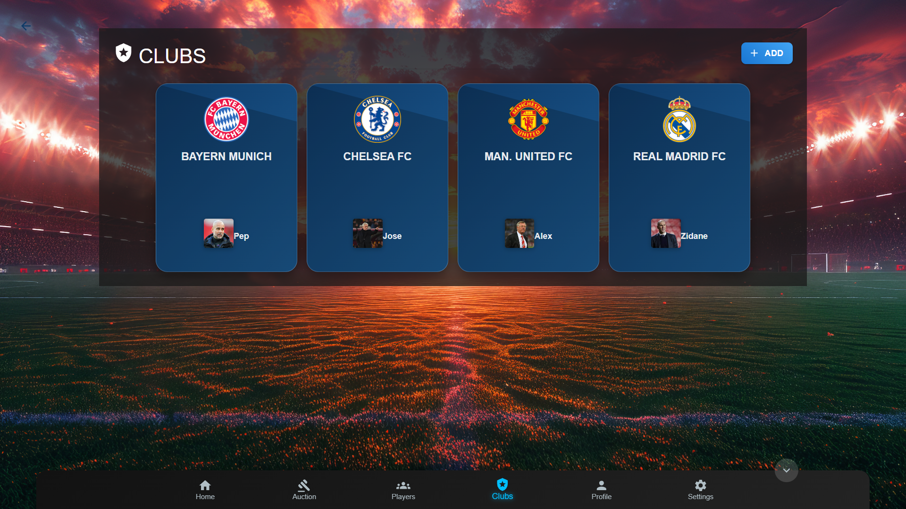

**Figure 4.5.5 Admin Clubs Page**

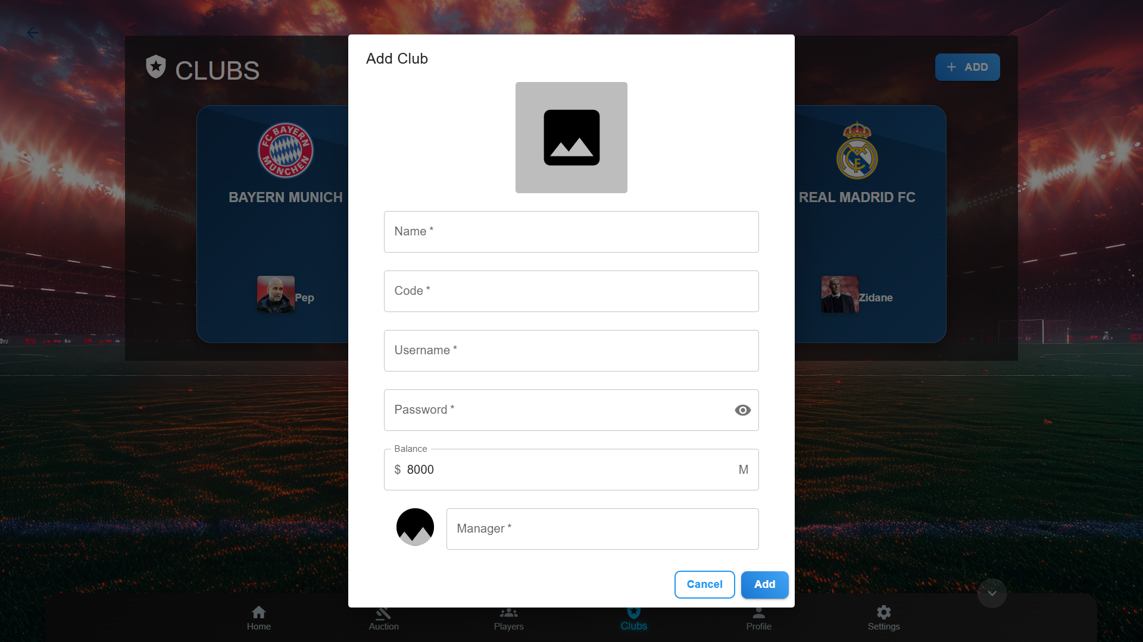

**Figure 4.5.6: Admin Add Club**

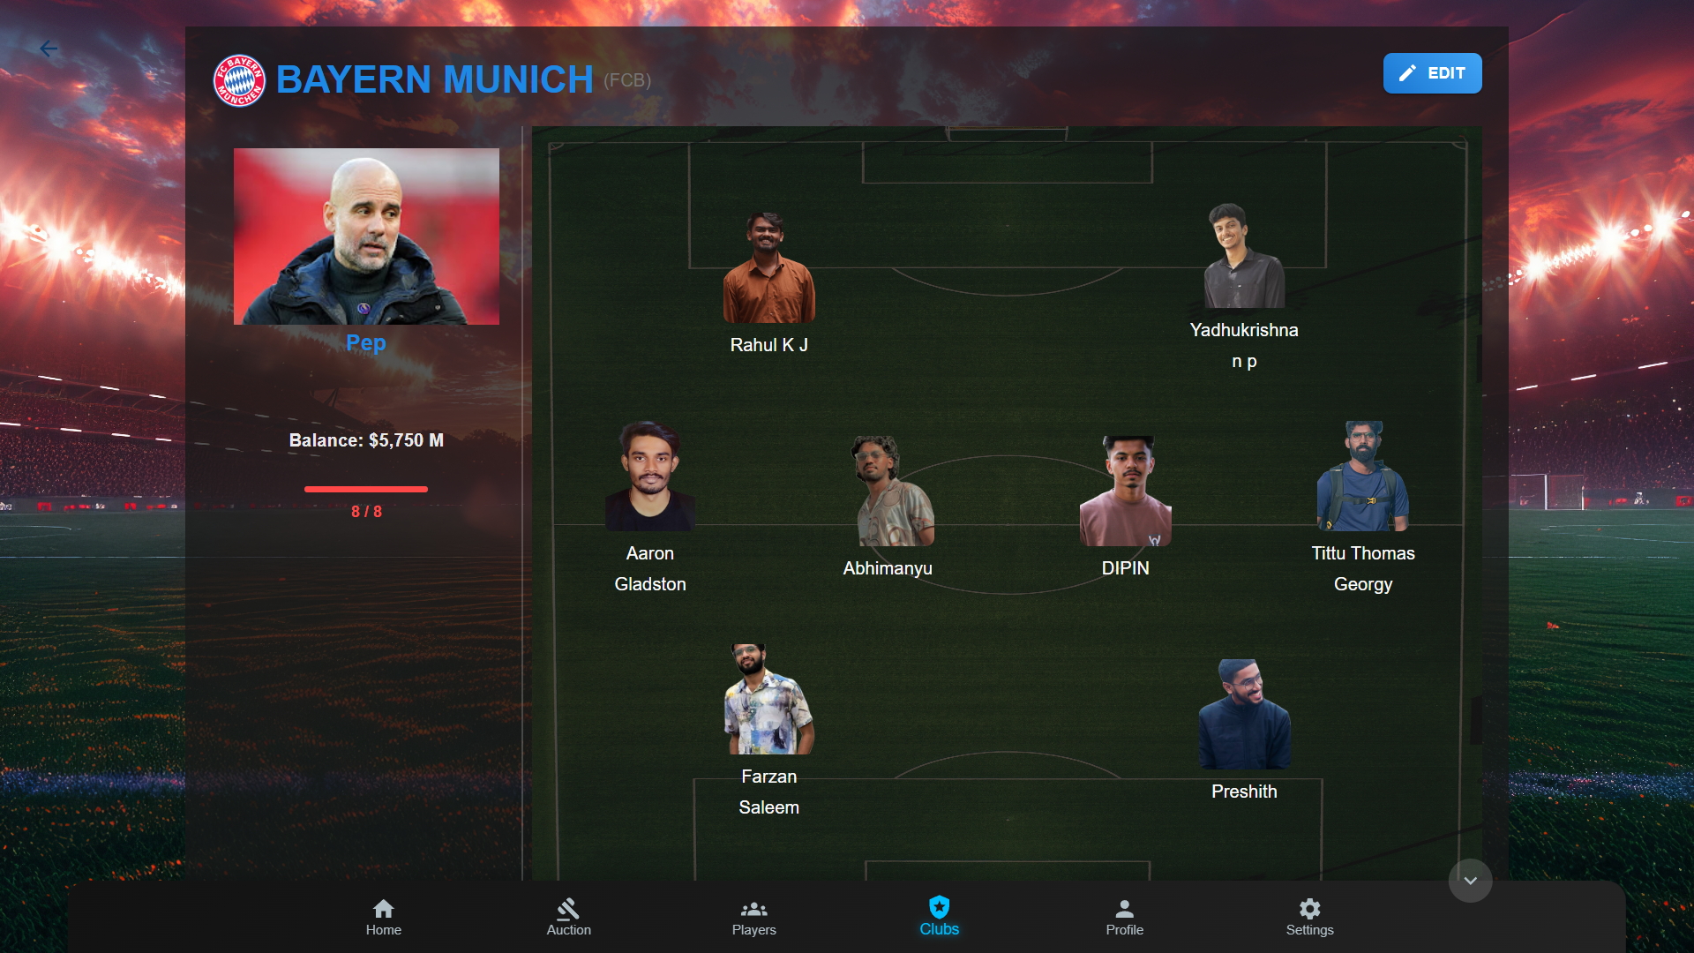**Figure 4.5.7 : Admin Club View**

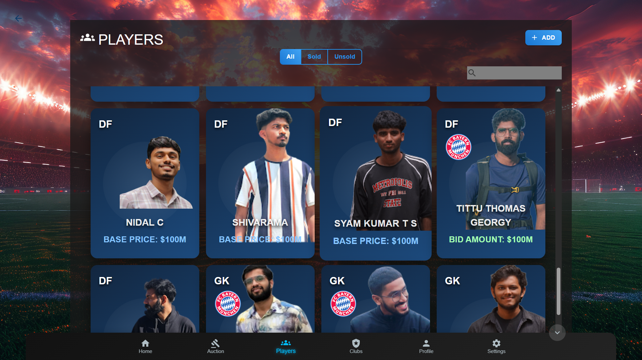

**Figure 4.5.8: Admin Players Page**

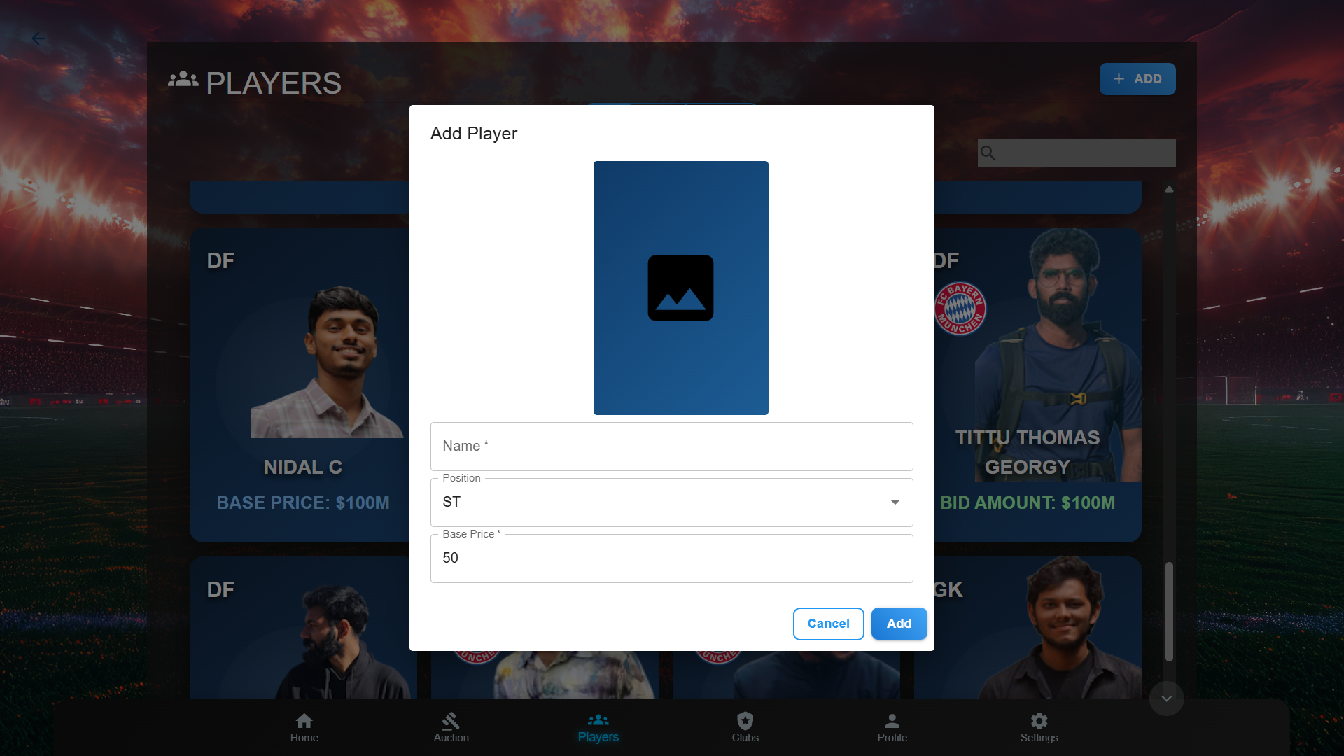

**Figure 4.5.9: Admin Add Player**



**Figure 4.5.10: Admin Player View**

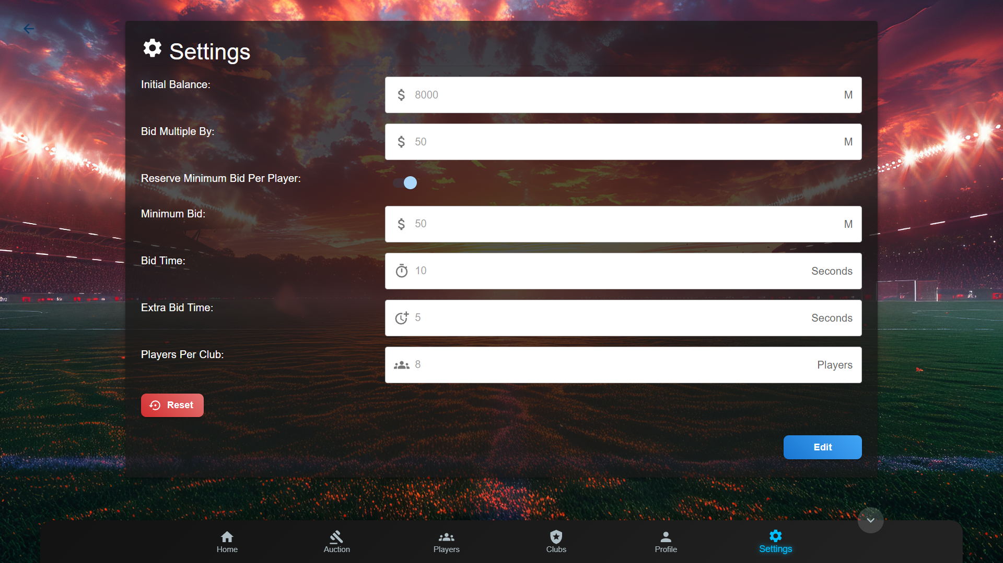**Figure 4.5.11: Admin Settings Page**

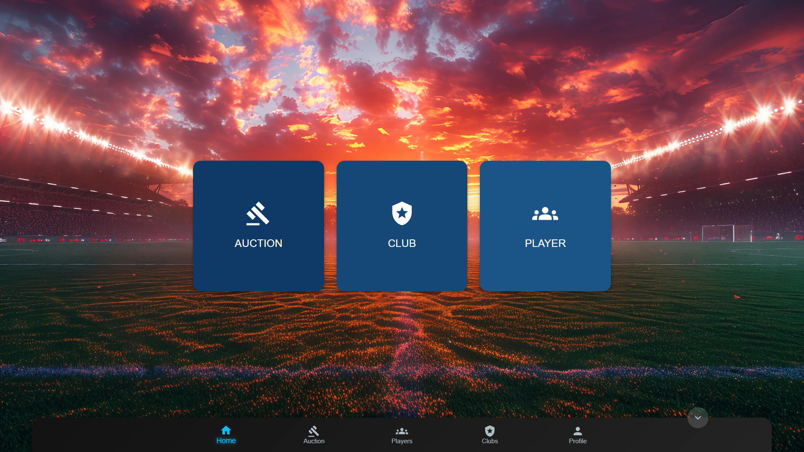

**Figure 4.5.12 : Club Homepage**

**Figure 4.5.13 : Club Auction Page**

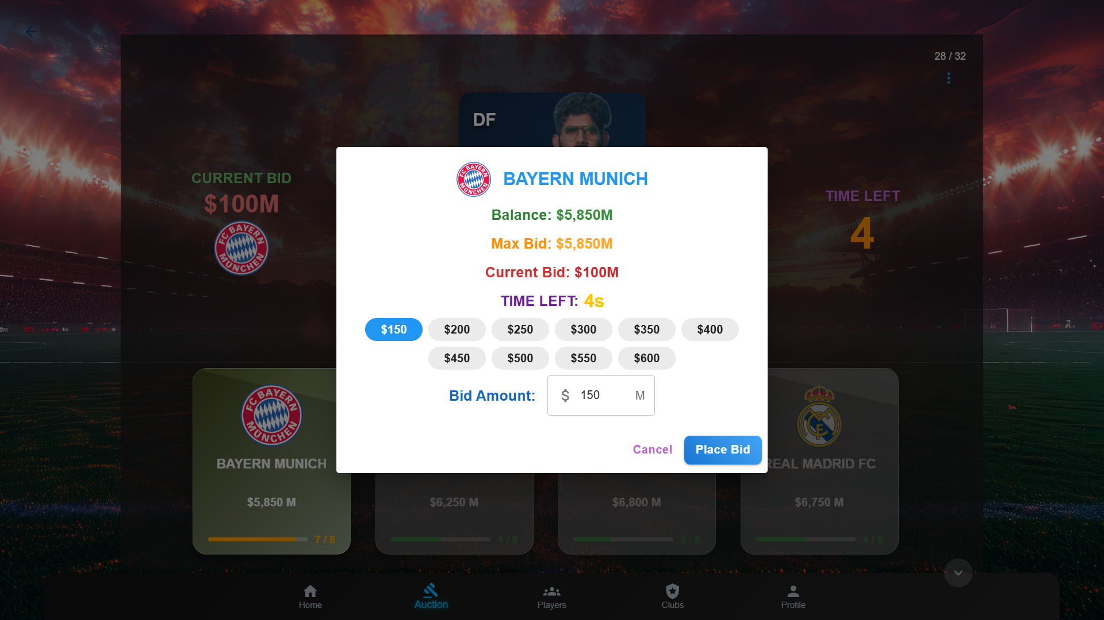

**Figure 4.5.14: Club Auction Place Bid**



**Figure 4.5.15: Club Player View**

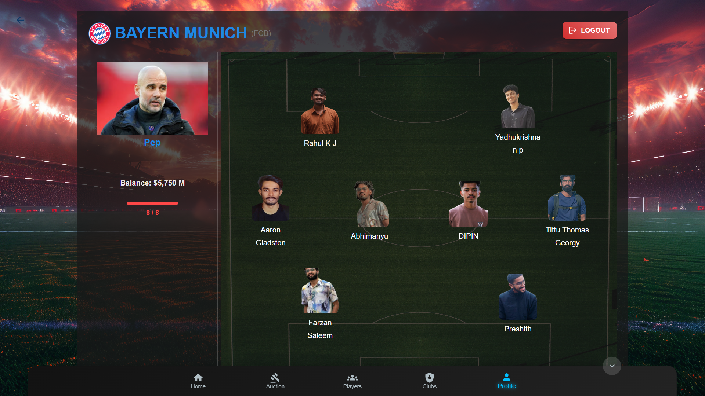

**Figure 4.5.16: Club Profile View**

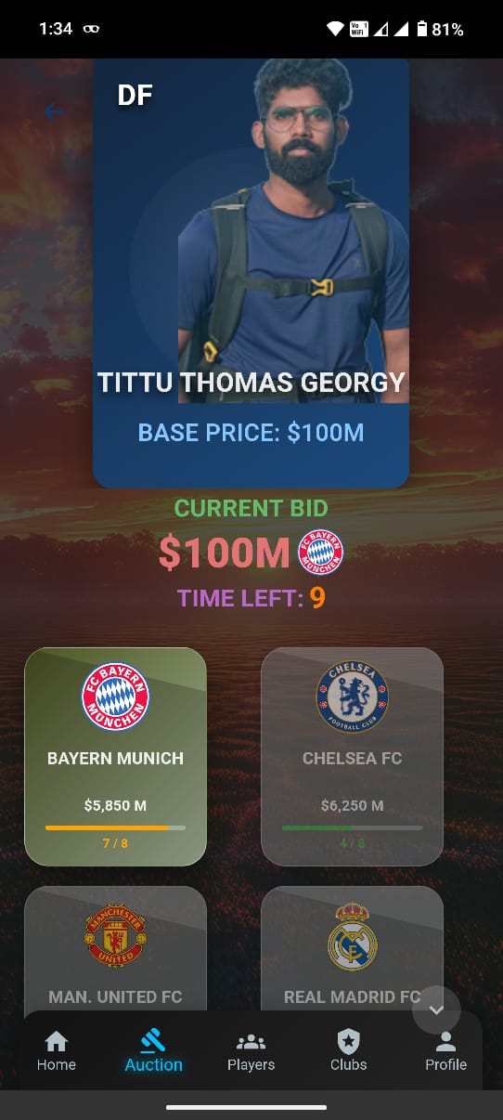

**Figure 4.5.17: Club Auction View Mobile**

**Chapter 5**

**Coding**

# **5.1 Introduction**

Coding is the process of transforming the system's design into a readable and executable format for a computer. This phase is crucial in software development as it translates design specifications into source code, making the system functional. Coding also involves writing internal documentation to facilitate future code maintenance and verification against the original design specifications.

In addition to immediate coding tasks, efficient coding practices are essential to reduce the long-term costs associated with the system, particularly those related to testing, maintenance, and future scalability. By following best practices in coding, developers ensure high-quality code that is easier to manage, update, and debug over time.

# **5.2 React JS**

React is a widely used JavaScript library developed by Facebook for building dynamic and interactive user interfaces, especially suitable for single-page applications that require high responsiveness. React allows developers to build reusable UI components that automatically update when the data changes, providing a seamless user experience.

For the Auction platform, React was chosen due to its efficiency in creating a highly interactive, component-based UI that meets the needs of the admin and bidder modules. React’s unidirectional data flow and virtual DOM mechanism ensure optimal performance, even as the application scales. The React ecosystem also offers tools like React Router for navigation and state management libraries such as Redux, making it well-suited for complex applications like auctions. Additionally, React’s extensive community support and flexibility allow for quick iteration and implementation of features, ensuring a robust and scalable frontend architecture for the auction platform.

# **5.3 Express JS**

Express JS is a fast, minimalistic framework for Node.js that simplifies the process of building server-side applications and web APIs. It provides essential features like routing, middleware support, and HTTP request handling, making it ideal for building RESTful APIs and backend services.

For the Auction platform, Express was selected as the backend framework due to its flexibility, scalability, and ease of use. Express simplifies the handling of bid data, user authentication, and real-time communication for the auction. It also enables efficient routing for different modules such as Admin and Club Bidder, ensuring smooth communication between the frontend and backend. Additionally, Express can be easily integrated with other Node.js modules and WebSocket for real-time functionalities, making it a perfect fit for the real-time, interactive nature of the auction platform.

# **5.4 Material-UI (MUI)**

Material-UI (MUI) is a popular React component library based on Google's Material Design principles. It offers a wide range of pre-designed components that adhere to modern UI standards, providing a consistent, visually appealing, and responsive interface. MUI helps speed up the development process by reducing the need for custom CSS while maintaining flexibility for further customization.

For the Auction platform, MUI was chosen for its polished and professional user interface components, which are essential for creating a smooth and intuitive experience for both admins and bidders. MUI’s built-in theming system allows for easy customization, ensuring the platform can maintain a cohesive look and feel throughout. The library also supports responsive design, making it adaptable across various devices and screen sizes, which is crucial for ensuring a seamless experience for users regardless of the device they are using.

By integrating MUI, the Auction platform can deliver a consistent and modern visual design, while reducing the time and effort spent on designing and styling custom components.

# **5.5 Sample Coding**

**5.5.1 App.tsx**

import { ThemeProvider } from "@emotion/react";

import { setupIonicReact, IonApp } from "@ionic/react";

import { createTheme, CssBaseline } from "@mui/material";

import axios from "axios";

import { useMemo, useEffect } from "react";

import CommonServices from "./services/CommonServices";

import { useLoader } from "./hooks/Loader";

import { enqueueSnackbar, SnackbarProvider } from "notistack";

import Router from "./services/CommonRouter";

import { AuctionProvider } from "./hooks/AuctionProvider";

import { AuthProvider } from "./hooks/Authenticate";

// Initialize Ionic

setupIonicReact();

// Configure Axios

const serverURL = import.meta.env.VITE_SERVER_URL || `http://192.168.1.7:8005`;

axios.defaults.baseURL = serverURL;

// console.log("Server URL:", serverURL);

const App: React.FC = () => {

// Set up common services

CommonServices.setLoader(useLoader());

CommonServices.setEnqueueSnackbar(enqueueSnackbar);

const theme = useMemo(

() =>

createTheme({

palette: {

background: {

default: '#000000'

},

primary: {

main: '#2196f3', // Primary blue

},

secondary: {

main: '#ba68c8', // Secondary purple

},

success: {

main: '#66bb6a', // Green for success

},

error: {

main: '#e57373', // Red for errors

},

warning: {

main: '#ffa726', // Orange for warnings

},

info: {

main: '#29b6f6', // Light blue for informational

},

},

}),

[]);

return (

<IonApp>

<ThemeProvider theme={theme}>

<CssBaseline />

<SnackbarProvider>

<AuthProvider>

<AuctionProvider>

<Router />

</AuctionProvider>

</AuthProvider>

{/* <div>hi</div> */}

</SnackbarProvider>

</ThemeProvider>

</IonApp>

);

};

export default App;

**5.5.2 server.ts**

import colors from 'colors';

colors.enable();

import express, { Request, Response } from 'express';

import http from 'http';

import dotenv from 'dotenv';

import mongoose, { Types } from 'mongoose';

import morgan from 'morgan';

import cors from 'cors';

import router from './modules/router';

import { sendStandardResponse } from './common/extras/helpers';

import WebSocket from 'ws';

import Google from './extras/google';

import{createSettings,isSettingExist} from ‘./modules/settings/controllers/settings.controller';

import Club from './modules/club/models/Club';

import { Server } from 'socket.io';

import { auctionEvents } from './modules/auction/apis';

import { createAuction } from './modules/auction/controllers/auction.controller';

import Bid from './modules/auction/models/Bid';

dotenv.config();

const PORT = process.env.PORT;

if (!PORT) {

throw new Error('PORT not found in environment variables!');

}

const app = express();

const server = http.createServer(app);

app.use(express.urlencoded({ extended: true }));

app.use(express.json());

app.use(morgan('dev'));

app.use(cors());

app.use(router);

app.use((error: Error, req: Request, res: Response) => {

console.info('Caught error by the error handler!!!');

// log the error

sendStandardResponse(res, 'INTERNAL SERVER ERROR', {

error: error.message, message: 'Oops! Something went wrong! We\'re working on it!',

});

});

app.use((req: Request, res: Response) => {

console.log('Received an error event!'.bgRed, new Error(`404 Found for ${req.url}`));

sendStandardResponse(res, 'NOT FOUND', {

error: '404 Not Found (REST API Endpoint not implemented)',

message: 'Oops! Something went wrong! We\'re working on it!',

});

});

console.log('Trying to connect to mongodb'.yellow);

mongoose.connect('mongodb://127.0.0.1:27017/auction')

.then(async () => {

console.log('Connected to mongodb'.bgGreen);

await createSettings();

await createAuction();

// await Bid.updateMany({}, { state: 1 })

})

.catch((error) => console.log('Received an error event!'.bgRed, error));

app.listen(PORT, () => console.log(`Server running: http://localhost:${PORT}`.bgGreen))

.on('error', (error) => console.log('Received an error event!'.bgRed, error));

Google.Drive.initialize(Google.Auth.getAuth()); // GoogleMail

const io = new Server(server, {

cors: { origin: '*' }, // Allow frontend to connect

});

let client: { id: string, no: number }[] = [];

// Attach event listeners for the connection

io.on('connection', (socket) => {

if (!client.find(client => client.id === socket.id)) {

client = [...client, { id: socket.id, no: client.length + 1 }]

}

// io.disconnectSockets(true)

console.log('Active connections:', io.engine.clientsCount);

console.log('New client connected:', client);

auctionEvents();

socket.on('disconnect', () => {

console.log('Client disconnected:', socket.id);

});

});

// Start the server

server.listen(process.env.SOCKET_PORT, () => {

console.log(`Socket Server running on http://localhost:${process.env.SOCKET_PORT}`);

});

// Export io for use in other files

export { io };

**Chapter 6**

**Testing and Implementation**

# **6.1 Introduction**

System testing is an essential part of the software development life cycle, ensuring that the system performs as expected before it goes live. The testing process follows a detailed system test plan, which outlines the specific testing activities, schedule, and resources needed. It also includes the identification of test cases and expected results for each case. The goal of system testing is to identify errors, validate the system's accuracy and efficiency, and ensure that the software functions correctly across different environments. System testing helps ensure the system's reliability, minimizing the chances of issues arising post-deployment.

# **6.2 Testing Methods**

# **6.2.1 Unit Testing**

Unit testing involves verifying the smallest components of the software, known as modules, to ensure they function as expected in isolation. During the development stage, each module is tested separately to confirm it performs its intended functionality. For the Auction platform, key modules like User Authentication, Bidding Logic, Payment Processing, and Admin Management will be tested individually. Each form or function within these modules is tested to ensure the expected output is produced. The purpose of unit testing is to catch errors early in the development process and ensure that individual components work correctly before integration.

# **6.2.2 Integration Testing**

Once unit testing is completed, integration testing combines all the individual modules into a complete system and tests them as a whole. This phase focuses on verifying that data flows seamlessly across different modules and interfaces. Integration testing checks whether the system's components work together as expected, ensuring that there are no data losses, mismatches, or conflicts between modules. This step is crucial as issues can arise when

different functions are integrated, and errors may be difficult to isolate. The goal is to identify and resolve any issues that occur when the individual modules are combined.

# **6.2.3 Alpha Testing**

Alpha testing is performed by the internal development team before the software is released to external users. It is usually conducted in a controlled environment, where developers observe the application's performance and identify any issues or defects. The focus of alpha testing is to simulate real user tasks using both black-box and white-box techniques. Developers attempt to find bugs or usability issues by performing actions that an end user might typically perform. Minor design changes may still be possible after alpha testing, allowing the team to fine-tune the application before moving to external testing phases.

# **6.2.4 Beta Testing**

Beta testing is conducted by real users in a real-world environment, making it an important form of external user acceptance testing. A beta version of the Auction platform is released to a limited group of users, typically chosen from the actual end-users (e.g., bidders or administrators). Feedback collected from these users helps identify any bugs or issues that might have been overlooked during internal testing phases. Beta testing not only provides valuable insight into the product’s quality but also serves to validate the product's features and functionality. This phase helps ensure that the platform performs as expected in diverse real-time environments, improving the overall user experience and boosting customer satisfaction before the final release.

# **6.3 Test Cases**

Test cases are a critical component of the software testing process. They consist of predefined conditions or inputs used to verify whether a software application behaves as expected under specific circumstances. Each test case includes details such as input data, expected output, and the steps to be followed during testing. Test cases serve as a guide for testers to systematically verify the system’s functionality, identify errors, and ensure the software meets its requirements. For the Auction platform, sample test cases would include verifying bid placement, checking user login functionality, confirming the payment process, and ensuring real-time updates during the auction process.

**1. Admin Functionalities**

|  |  |  |  |
| --- | --- | --- | --- |
| **Test Case ID** | **Description** | **Input** | **Expected Output** |
| ADM-001 | Create new player | Valid player info | Player saved in DB |
| ADM-002 | Create duplicate player | Existing player name or ID | Error: duplicate key |
| ADM-003 | Update auction settings | Valid config values | Settings updated |
| ADM-004 | Upload player image | Valid image file | File uploaded & linked |
| ADM-005 | View all registered clubs | None | List of clubs returned |

**Table 6.3.1: Admin Test Cases**

#### **2. Club Functionalities**

|  |  |  |  |
| --- | --- | --- | --- |
| **Test Case ID** | **Description** | **Input** | **Expected Output** |
| CLB-001 | Register club | Valid name, username, password | Club saved to DB |
| CLB-002 | Login with valid credentials | Correct username/password | Token or success response |
| CLB-003 | Login with wrong password | Invalid password | Error: authentication failed |
| CLB-004 | Place bid on player | Bid amount > current bid | Bid saved, player updated |
| CLB-005 | Place bid with insufficient balance | High bid amount | Error: insufficient funds |
| CLB-006 | Exceed player limit | More than playersPerClub | Error: max players reached |

**Table 6.3.2: Club Test Cases**

#### **3. Player Auction**

|  |  |  |  |
| --- | --- | --- | --- |
| **Test Case ID** | **Description** | **Input** | **Expected Output** |
| AUC-001 | Start auction | Valid player selected | Auction status: live |
| AUC-002 | End auction manually | Valid auction ID | Status: stopped |
| AUC-003 | Auto-extend auction | Bid placed at last second | Auction time extended |
| AUC-004 | Assign player to winning club | Auction end reached | Player's club updated |
| AUC-005 | Pause auction | Admin triggers pause | Auction status: pause |

**Table 6.3.3: Player Test Cases**

#### **4. File Uploads**

|  |  |  |  |
| --- | --- | --- | --- |
| **Test Case ID** | **Description** | **Input** | **Expected Output** |
| FIL-001 | Upload valid image | PNG/JPG image | File stored in DB |
| FIL-002 | Upload unsupported format | PDF or GIF | Error: invalid format |
| FIL-003 | Upload large image | > 5MB | Error: file too large |

**Table 6.3.4: File Uploads Test Cases**

#### **5. Settings Validation**

|  |  |  |  |
| --- | --- | --- | --- |
| **Test Case ID** | **Description** | **Input** | **Expected Output** |
| SET-001 | Save default settings | Values like minBid, bidTime | Settings saved |
| SET-002 | Save with missing field | Omit bidTime | Error: field required |
| SET-003 | Use invalid bid multiple | Negative or 0 | Error: invalid value |

**Table 6.3.5: Settings Test Cases**

#### **6. Database Integrity Tests**

|  |  |  |  |
| --- | --- | --- | --- |
| **Test Case ID** | **Description** | **Input** | **Expected Output** |
| DB-001 | Save player without base price | No basePrice field | Default to 100 |
| DB-002 | Save club with duplicate username | Same username | Error: duplicate key |
| DB-003 | Delete a club | Club ID | Cascade not allowed on players (ensure consistency) |

**Table 6.3.6: Database Integrity Test Cases**

**Chapter 7**

**Results and Discussion**

# **7.1 Advantages and Limitations**

# **7.1.1 Advantages**

* **Centralized Event Management:** The Auction platform simplifies event management by offering centralized control, allowing admins to oversee and manage the entire auction process in one place. This centralization reduces the complexity of handling multiple platforms and streamlines event coordination.
* **User-Friendly Interface:** A well-designed and intuitive user interface ensures that all users—admins, bidders, and participants—can easily navigate the platform. This user-centric design improves overall user experience and allows users to focus on their core tasks without being hindered by complex workflows.
* **Efficient Registration Process:** The Auction platform features a seamless online registration system, which automates user sign-ups, bid placements, and notifications. This reduces the workload for administrators, as it eliminates the need for manual data entry and enhances overall system efficiency.
* **Real-Time Updates:** With the auction running in real-time, participants and admins can receive immediate updates about bids, auction status, and any changes made. This ensures that everyone involved in the process is kept up to date with the latest developments, allowing for better decision-making and engagement.
* **Results and Evaluation Tracking:** Automated tracking of bids, payments, and auction results ensures accuracy. By automating the evaluation process, the platform reduces the chances of human error, providing transparency and fairness throughout the auction.
* **Convenient Access:** The platform is accessible from any device, allowing bidders and admins to access auction information, place bids, and check results from anywhere, thus increasing convenience and flexibility.
* **Approval-Based Signup:** Admins can approve or reject bids based on predefined criteria, giving them full control over who can participate. This security feature
* ensures that only eligible and authorized users can access sensitive event data and place bids.
* **Scalability and Flexibility:** The platform is designed to scale, allowing the addition of new features and the accommodation of multiple event types, making it adaptable for various auction scenarios. This flexibility makes the system suitable for a range of use cases, from small-scale to large-scale auctions.
* **Enhanced Security:** The platform incorporates robust security measures, including secure access control and data encryption, ensuring that all user data, bid information, and payment transactions are protected against unauthorized access and potential breaches.

# **7.1.2 Limitations**

* **Dependency on Internet Connectivity:** As the platform is cloud-based, users require stable internet connectivity to participate in auctions. This can be a limitation in regions where internet access is unreliable or unavailable, potentially excluding certain users from the auction process.
* **Limited Offline Support:** Currently, the platform is designed exclusively for online use. There is no support for offline or hybrid auction models, meaning that the system cannot be utilized for in-person events without internet access. This limitation could affect its applicability in certain environments or scenarios.
* **Initial Learning Curve:**Although the interface is user-friendly, some new users, especially those who are not familiar with online auction systems, may experience an initial learning curve. Proper training and onboarding materials are required to help users quickly get up to speed with the platform’s features and functionalities.
* **Maintenance and Updates:** Continuous updates and maintenance are crucial to ensure the platform stays secure, efficient, and compatible with evolving technologies. Regular patches, bug fixes, and updates to improve functionality are necessary, requiring ongoing developer resources and attention.

**Chapter 8**

**Conclusion and Future Scope**

# **8.1 Conclusion**

In conclusion, the **Auction Platform** provides a comprehensive solution for managing online auctions with multiple bidders. The system enables a seamless experience for **Admin** and **Club Bidders** to participate in and manage auctions effectively. Using modern web technologies like **Node.js with Express** for the backend and **React with Material-UI** for the frontend, the application delivers an interactive and user-friendly interface. The platform ensures smooth real-time bidding, transparent bid tracking, and secure data management, contributing to an efficient auction process.

While the platform offers scalability, real-time functionality, and secure user authentication, there are challenges such as internet connectivity dependency and the need for better support across various devices. These limitations will be addressed in future updates to enhance the user experience. The **Auction Platform** is designed to evolve with the growing needs of users, making it a robust tool for managing online bidding in a secure and efficient manner.

# **8.2 Future Scope**

* **Player Stats and Analytics::**Integrating player statistics and analytics (e.g., performance history, match statistics, etc.) for each player in the auction would allow bidders to make more informed decisions based on detailed data. This could include visual charts, graphs, and historical performance insights.
* **Advanced Bidding Features:** Introducing advanced bidding features, such as **auto-bidding** where users can set maximum bid amounts, or **bid increments**, would provide more flexibility and functionality to the bidding process.
* **Multiple Auction Types:** Expanding the platform to support multiple auction formats, such as **silent auctions**, **reverse auctions**, and **Dutch auctions**, would increase the platform's adaptability and usability for different auction scenarios.
* **Extended Payment Gateway Integration:** Adding more payment options, including cryptocurrency and regional payment gateways, would expand the accessibility of the platform and provide more flexibility for users.
* **Enhanced Security Features:** Implementing advanced security measures, such as **two-factor authentication** for bidders and **end-to-end encryption** for transactions, would help further secure the platform against unauthorized access and fraud.
* **Auction Analytics and Reports:** Integrating advanced analytics to track auction performance, bidder activity, and item popularity would provide valuable insights for both admins and bidders, helping them make more informed decisions in future auctions.
* **Bidder Notifications and Alerts:** Implementing a customizable notification system to alert bidders when they are outbid or when an auction is about to close would enhance the user experience by keeping them informed in real time.
* **Mobile App Development:** Developing a mobile application for both **iOS** and **Android** would make it easier for bidders to participate in auctions from anywhere and at any time, improving the overall accessibility and engagement.
* **AI-Based Auction Insights:** Using artificial intelligence to suggest bidding strategies, identify high-value items, or recommend auctions to users based on their past activity would personalize the user experience and improve bidding success.

**Bibliography**

1. **MongoDB Documentation**MongoDB, Inc. (2024). *MongoDB Manual*. Retrieved from<https://www.mongodb.com/docs>
2. **Express.js Documentation**Express Contributors. (2024). *Express.js Documentation*. Retrieved from<https://expressjs.com/>
3. **React Documentation**React Contributors. (2024). *React – A JavaScript library for building user interfaces*. Retrieved from<https://reactjs.org/>
4. **Node.js Documentation**Node.js Foundation. (2024). *Node.js Documentation*. Retrieved from https://nodejs.org/en/docs/
5. **Mongoose Documentation**Automattic. (2024). *Mongoose – MongoDB object modeling for Node.js*. Retrieved from<https://mongoosejs.com/>
6. **Material-UI Documentation**Material-UI Contributors. (2024). *Material-UI – React components for faster and easier web development*. Retrieved from<https://mui.com/>
7. **NPM Documentation**NPM, Inc. (2024). *npm Documentation*. Retrieved from [https://docs.npmjs.com](https://docs.npmjs.com/)/
8. **Ethan Brown**Brown, E. (2019). *Web Development with Node and Express: Leveraging the JavaScript Stack* (2nd ed.). O'Reilly Media.
9. **Kirupa Chinnathambi**Chinnathambi, K. (2018). *Learning React: A Hands-On Guide to Building Web Applications Using React and Redux* (2nd ed.). Addison-Wesley Professional.